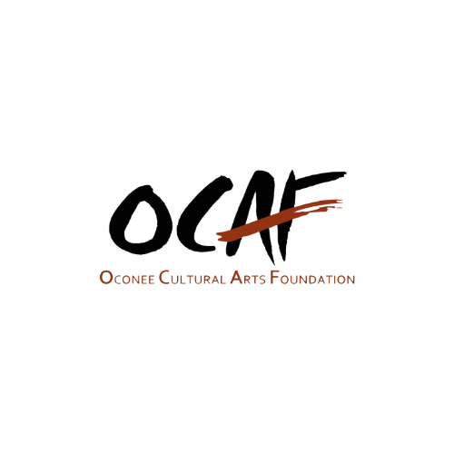
OCAF Board of Directors
Regular Meeting Minutes
October 10, 2024 |4 p.m. | School Street Studios
Attendance: Rob Farley, Abbey Duhe, Judy Marable, Kathie Anderson, Jim Norton, Eadaoin Walsh, Sherry Woodruff, and Vicky Moody
Paul Clark, Executive Director
Absent: Brock Toole, Paula Williams, John Quackenbush, Betty Walton, Lawrence Stueck

Abbey Duhe called the meeting to order at 4:03 p.m. in the absence of Chairman Brock Toole. It was determined that a quorum was present.

There were no members who signed up to offer comments to the Board.
Jim Norton moved to accept the September 12, 2024 regular board minutes. Rob Farley seconded. Secretary Judy shared that Jim had noted that Abbey’s name was misspelled in the minutes offered to the board for review. The minutes were approved unanimously.

Jim Norton moved to approve the meeting agenda for October 10, 2024 with adjustments to table some agenda items due to the absence of the presenters. Additionally, discussion of the Employee Handbook was added to the agenda. Eadaoin Walsh seconded the motion. The agenda with the forementioned changes was approved unanimously.

Reports of Officers & Standing Committees
- Chairperson Brock Toole
- In the absence of Chairman Toole there was no report.
- Vice Chair Abbey Duhe´
- No report.
- Secretary Judy Marable
- No report.
- Treasurer Paul Clark
  - Due to the absence of John Quakenbush, Paul Clark distributed copies of the financial report to the board members and reminded us that the documents were emailed to all board members also. He reported that Perspectives checks were mailed today to the potters. They took extra time to ensure accuracy. The totals will be about the same as last year. No obvious trends in the budget are surfacing yet. We appear to be maintaining, but we have not created any momentum.
- Executive Director Report Paul Clark
  - Paul offered an upcoming transition to a new system for artist inventory management which would involve a barcode system for sales and inventory. He acknowledged that this may be change that could be challenging. Paul also discussed the potential use of wireless devices for marketing and transactions and the possibilities of using QR codes for ticket purchases at events. The question was asked if we would test prior to going live. Paul responded yes. He shared the plans for the Fall Festival and upcoming camps. Paul also discussed membership and encouraging attendees to support OCAF. Also, the team is planning a young professional drive to encourage younger individuals to come and see what we have to offer. An email campaign will be launched to target individuals who have not renewed their membership over the past year. He noted that membership is lower than this time last year.
- Paul proposed three separate fundraising drives: a Fall 50 Drive to raise $50,000 by Thanksgiving for expanding OCAF programs such as performing arts and facility improvements, a drive on Giving Tuesday with a specific goal and celebration event, and an end of the year drive for tax write offs. Board discussion included creating an itemized wish list of needed resources like easels and educational materials to motivate donors. Board members expressed concerns about the aggressiveness of the $50,000 goal within such a short time frame and offered suggestion to adjust the amount or combine the campaigns. Discussion also included sliding scales for fees for inclusion for all. The board communicated that the campaigns should be designed to educate the donors and public about the costs of programs rather just donating money without knowing how the money was being spent. The board will need to finalize the dates for the funding campaigns.
- Paul shared that he had met with UNG representatives regarding the facilities. He was given a list of improvements for the facility. The discussion also included increasing student engagement with the program. Numbers have decreased since Covid. The next meeting with UNG was scheduled for the beginning of the calendar year.
- Paul discussed the potential for a successful sponsorship program, emphasizing the need to demonstrate the benefits of sponsorship to potential sponsors. He mentioned the possibility of renting out Rocket Hall and offering discounts on classes to sponsoring members. He noted the importance of getting this out before the end of the calendar year for tax donations. It was also noted that more teachers are needed for classes. Rob Farley commented that a New Years Eve Party would be a wonderful way to generate funds while offering NYE party for guests. It was suggested to work with a professional event coordinator to handle the logistics. Vicky recommended having a dance performance for the New Years Eve Event.
- Paul shared with the board that a marketing meeting was recently held.
Reports of Special Committees
- Governance Committee Eadaoin Walsh
- Eadaoin shared that a volunteer handbook is in process that will be shared during an orientation. Ashten will be the volunteer liaison.
- Eadaoin also reminded us of the Employee Handbook that had been emailed to board members for review. She requested that any questions be offered to her by Thursday, October 17. This handbook has been vetted by several professionals in HR and legal representatives. Eadaoin moved that the Employee Handbook will be effective after October 17. Abbey seconded. The vote was unanimous.
- A draft of the by-laws was offered to each board member via email. Any questions or concerns should be communicated to Eadaoin and the by-laws will be on the agenda for November’s meeting. Several clarifications were offered. Discussion included have the 1902 Society be an open classification based on donations. It was also suggested that residency should not be a requirement to be on the board of directors.
- The board discussed the process of dissenting during a vote as noted in the by-laws. It was debated whether a dissenting opinion should be documented in writing and submitted immediately before adjournment or if it could be noted during the meeting or sent afterwards. The team agreed that dissent should be captured in a vote and the dissenting opinion should be documented within the confines in the meeting. Additional discussion regarding the by-laws included establishing a clear process for disciplining or removing board members from the board due to unexcused absences or other unacceptable conduct, while ensuring consistency with volunteer policies. The discussion included defining the authority of the committees versus the executive director as chief executive. It was mentioned in the bylaws the annual meeting was shifted to May to allow time for onboarding new board members prior to the beginning of the fiscal year and service. The bylaws will be discussed and finalized at the November meeting.

Unfinished Business
- The Discussion of OCAF Capital Project Proposal Form was tabled for the November meeting.
- Stancil Entrance Updates were tabled for the November meeting.
- Paul Clark shared with the board the updates regarding the Executive Director search. The job description is being finalized and he would be seeking board feedback. He communicated that Judy and Paula will serve on the committee and other members from OCAF membership would be included. He indicated that it is important to have people on the committee who have hiring experience.

New Business
- The discussion regarding Routine Maintenance and Operations was tabled for November due to Brock Toole’s absence.
A motion to Adjourn the October 10, 2024, Board of Directors meeting was made by Vicky Moody at 5:30 PM. The motion was seconded by Eadaoin Walsh. The meeting was unanimously voted to adjourn.

Attachments:

September Board Minutes
Attendance Record
Financial Report

